UNIVERSITY OF VETERINARY MEDICINE AND PHARMACY IN KOŠICE

DEPARTMENT OF FOOD HYGIENE AND TECHNOLOGY

STATE VETERINARY AND FOOD ADMINISTRATION

OF THE SLOVAK REPUBLIC

NATIONAL FOCAL POINT FOR TECHNICAL

AND SCIENTIFIC MATTERS FOR EFSA

HYGIENA ALIMENTORUM XXXVIII

INTERNATIONAL SCIENTIFIC CONFERENCE

under the auspices of Ministry of Agriculture and Rural Development
of the Slovak Republic

„SAFETY OF MEAT AND MEAT PRODUCTS IN SEARCHING FOR
TRADITIONAL QUALITY“

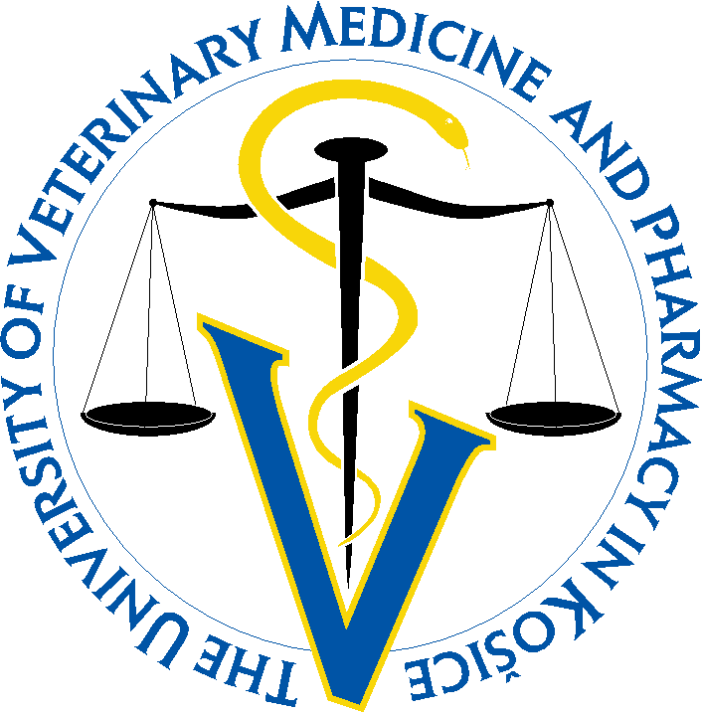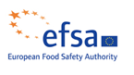



May 17 – 19, 2017

Štrbské Pleso – hotel Patria
Slovakia

GOALS OF INTERNATIONAL SCIENTIFIC CONFERENCE
The goal of the international scientific conference is to gain knowledge on production, health safety and quality of beef, pork, mutton, goat and horse meat in relation to intravital effects and implementation of the principles of animal welfare before slaughter. Focusing on new technologies and the level of hygiene of animals slaughter dressing and meat handling to ensure the health safety and quality. In the area of meat products is the goal to assess the health safety and quality, to gain knowledge on modern technological processes of production. Pointed out weaknesses in the quality and solutions to improve quality through the use of modern butchery technologies, application of ingredients and additives and packaging materials with reflecting traditional quality of meat products. Assessment of the state of implementation of European policy on the quality of meat products.

HEAD OF INTERNATIONAL PROGRAMME AND ORGANISING BOARD
TUREK Peter, prof., MVDr., PhD. E-mail: peter.turek@uvlf.sk

INTERNATIONAL PROGRAMME BOARD
BANIA Jacek, prof. Dr. hab.
Wrocław University of Environmental and Life Sciences, Poland
BÍREŠ Jozef, prof., MVDr., DrSc.
State Veterinary and Food Administration of the Slovak Republic
BÍROŠOVÁ Zuzana, Ing., CSc.
Ministry of Agriculture and Rural Development of the Slovak Republic
GOLIAN Jozef, prof., Ing., Dr.
Slovak University of Agriculture in Nitra, Slovak Republic
KOZAČINSKI Lidija, prof. dr.sc.
Faculty of Veterinary Medicine, University of Zagreb, Croatia
MARCINČÁK Slavomír, doc., MVDr., PhD.
State Veterinary and Food Institute, Dolný Kubín, Slovak Republic
NAGY Jozef, prof., MVDr., PhD.
University of Veterinary Medicine and Pharmacy in Košice, Slovak Republic
MOJŽIŠOVÁ Jana, prof., MVDr., PhD.
University of Veterinary Medicine and Pharmacy in Košice, Slovak Republic
OSEK Jacek, prof., DVM., PhD., ScD.
National Veterinary Research Institute, Pulawy, Poland
PAULSEN Peter, prof. Dr. Med. Vet. Dipl. ECVPH
University of Veterinary Medicine Vienna, Austria
RYBA Štefan, Ing., PhD.
Ministry of Agriculture and Rural Development of the Slovak Republic
TREMLOVÁ Bohuslava, doc., MVDr., CSc.
University of Veterinary and Pharmaceutical Sciences Brno, Czech republic
TUREK Peter, prof., MVDr., PhD.
University of Veterinary Medicine and Pharmacy in Košice, Slovak Republic

ORGANISING BOARD CONTACT
Popelka Peter, doc., MVDr., PhD.  Gereková Petra, Ing., PhD. | University of Veterinary Medicine and  Pharmacy in Košice
Jevinová Pavlína, MVDr., PhD. | Institute of Meat hygiene and Technology
Mačanga Ján, MVDr., PhD. | Komenského 73
Regecová Ivana, MVDr., PhD. | 041 81 Košice
Roba Pavol, MVDr. | Tel. č.: +421905910221; +421915922093
Bartkovský Martin, Mgr. | E-mail: eva.skovranova@uvlf.sk
Škovranová Eva | www.uvlf.sk
CONFERENCE FEE 125 € (we are not VAT payers)
Conference fee covered expenses for organisation and technical support, renting of conference places and audio-visual technique, simultaneous translation, publishing of proceedings.
Account number: 7000072225/8180
Variable symbol (VS):52016
Štátna pokladnica, Radlinského 32, 8100 05 Bratislava 15
IBAN: SK42 8180 0000 0070 0007 2225
SWIFT: SPSRSKBA
The fee is to be covered until May 10, 2017. Confirmation of payment of the registration fee must be submitted during the registration, in exceptional circumstances can be paid directly at the registration. In the note on the payment list the names of participants.

Board and lodging
Board and lodging are paid by participant.
Accommodation is arranged by participant.
Price of accommodation in hotel PATRIA:
2-bed room 75 €
1-bed room 60 €
(There is no 1-bed rooms in hotel, price is for a one person in 2-bed room)
Apartment 95 €
Reservation of accommodation entitled „hygiena alimentorum“:
Hotel Patria: tel.: +421 524492591-5, +421 527848999, e-mail: recepcia@hotelpatria.sk
Other hotels: Hotel FIS, Grand Hotel Kempinski High Tatras, Hotel Panorama Resort, Ubytovňa SHB Štrbské Pleso-Vysoké Tatry, Hotel Crocus

GUIDELINES FOR MANUSCRIPTS PUBLISHED IN PROCEEDINGS OF ABSTRACTS
- Abstract in English language write in Microsoft Word, Times New Roman 12, upper and lower margins 2.5 cm, left 3 cm, right 2 cm, A4 format, 1.5 line spacing. The maximum range 1 page
- Title of contribution: align text to centre, all signs large, bold
- The names of authors: without degrees, align text to centre, bold, write the omission of one line
- Author's address: align text to centre, italics
- Key words: max. 5
GUIDELINES FOR MANUSCRIPTS PUBLISHED IN PROCEEDINGS (CD)
- Contributions in English language write in text editor Microsoft Word, font Times New Roman 12, margins 2.5 cm, A4 format, 1.5 line spacing. Pages not numbered
- Title of contribution: align text to centre, all signs large, bold
- The names of authors: without degrees, align text to centre, bold, write the omission of one line
- Author's address: align text to centre, italics
- Abstract: align text to the edges; write the omission of one line
- Key words: max. 5
- Subheadings of paragraph, images, charts, tables: align text left, all signs large, bold
- Paragraphs: align text to the edges, followed a typical structure for scientific papers (introduction, materials and methods etc.). Figures and tables placed in the text, title above the table and under the figure
Contributions that do not meet these guidelines will be returned to author for revision. The organizers reserve the right to select contributions.
Contributions (Abstracts and full text) should be sent by email (peter.popelka@uvlf.sk or peter.popelka73@gmail.com) at the latest April 21, 2017.

GUIDELINES FOR LECTURES
Time for plenary lecture is 25 minutes and for lecture 15 minutes in Slovak, Czech and/or English language.
GUIDELINES FOR POSTERS
Poster size: 90 cm x 120 cm in PowerPoint, presentation of posters will be in electronic form. Posters must be sent at the latest April 21, 2017 on abovementioned e-mail addresses.

AFFIRMATION FORM
International scientific conference
HYGIENA ALIMENTORUM XXXVIII
„Safety of meat and meat products in searching for traditional quality“

May 17 – 19, 2017
Štrbské Pleso, High Tatras

Surname, Name, Title:
.......................................................................................................................................................
Address: ........................................................................................................................................
................................................................................ZIP...............................................................
E-mail: ...................................................................Tel.: ...............................................................

Participation: active □ passive □

Active participation:

Author(s) and title of lecture:

.......................................................................................................................................................
.......................................................................................................................................................
.......................................................................................................................................................
Author(s) and title of poster:
.......................................................................................................................................................
.......................................................................................................................................................
.......................................................................................................................................................
Participant, who requires tax document (invoice) about payment of registration fee must send at the latest April 30, 2017 on contact address following information: precise name of organisation, Identification number, VAT identification number, names of participants, total amount of registration fee.

Order of company presentation – uniform fee for each form of presentation 280 €
□ Presentation table during conference
□ Presentation in form of lecture
□ Panel presentation
□ Advertisement in proceedings

Please send us back the AFFIRMATION FORM until April 21, 2017 on the address of Organising board.

 Journal MASO is media partner of the conference

